1. A revision (possibly an expansion, a reduction, a refinement, or whatever is needed) of your project that you developed in phase 1, possibly through more requirement analysis performed together with the user.

* We have modified the relational schema to include more entities. We originally only had 1 entity in the diagram (specimen), with the existing attributes, as well as the attributes of location, and species. We decided that, since location and type are categories with subtypes, they make more sense as entities.
* Originally, the professor seemed to only want a table to display all of the data together, however, we believe that she has underestimated us, and so we plan on doing that, as well as creating functionality for summarizing the data.
* In terms of the technical aspect, we plan on using PostgeSQL/Next.js for the database/backend, and believe that, since it is likely that the App will have many states based on user input, a React frontend makes the most sense.
* Additional revisions to come following 10/18/23 meeting with Prof. Riondato and Prof. Miller

1. A tentatively final ER schema of your database.

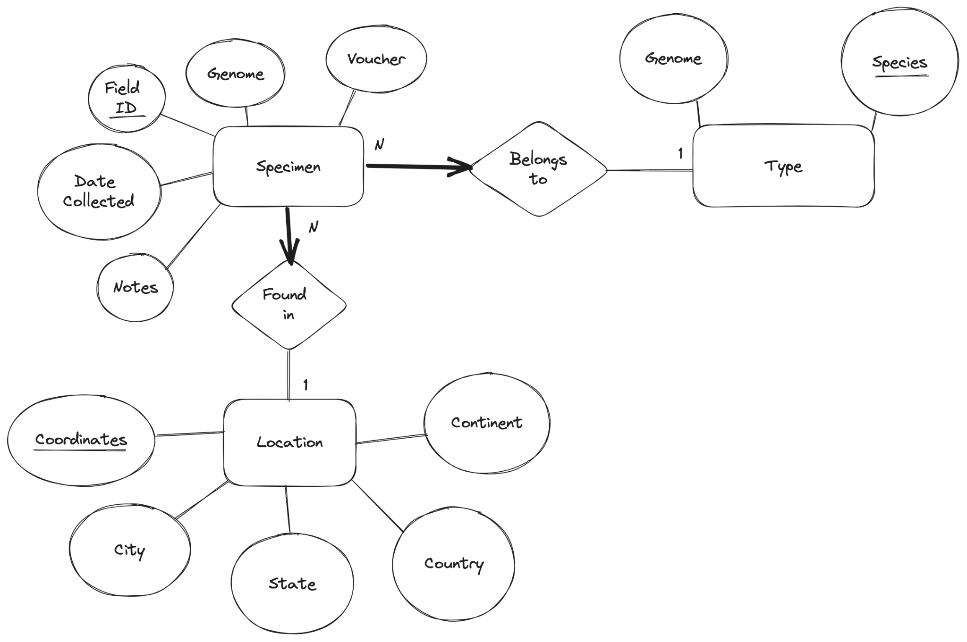

1. An initial translation of the ER schema into a relational schema.

**CREATE TABLE Specimen(**

**species CHAR(20) NOT NULL,**

**coordinates CHAR(25) NOT NULL**

**field_id CHAR(15),**

**genomic Integer,**

**voucher CHAR(20),**

**notes CHAR(256),**

**collection_date DATE,**

**PRIMARY KEY (field_id),**

**FOREIGN KEY (species) REFERENCES Type,**

**FOREIGN KEY (coordinates) REFERENCES Location)**

**CREATE TABLE Type(**

**field_id CHAR(15)**

**species CHAR(50) NOT NULL,**

**genome CHAR(50) NOT NULL,**

**PRIMARY KEY(species)**

**FOREIGN KEY (field_ID REFERENCES Specimen ON DELETE CASCADE)**

**)**

**CREATE TABLE Location (**

**field_id CHAR(15)**

**coordinates INTEGER NOT NULL**

**continent CHAR(10)**

**country CHAR(20)**

**state CHAR(85)**

**city CHAR(85)**

**PRIMARY KEY (coordinates)**

**FOREIGN KEY (field_ID REFERENCES Specimen ON DELETE CASCADE)**

**)**

1. A first assignment of roles to your team members for phase 3.

**Backend:**

Tania, Ryan

**Frontend:**

Charlie, Claudiu

**PostgreSQL**:

Charlie, Claudiu, Ryan, Tania

1. A list of open questions about your project, which you plan to answer in phase 3.

* How can we manipulate data to make a project more beneficial? We are considering showing students’ research that has used materials from the database.
* How can we add more relationships between entities?
* Can we keep and utilize entities like COS30, or ITS to make a project more interesting?
* What backend framework makes the most sense to use, alongisde postgres?
* Would React be helpful for frontend development, or overkill?
* Does the professor just want the data to be displayed, or should it be summarizable, displayed on a map, etc.?
  + What will the site be used for, specifically?
* Does a 2 table relational schema (current) make more or less sense than a 1 table schema?